MAIN SUB PAGE
STEEL SIDING & SOFFIT
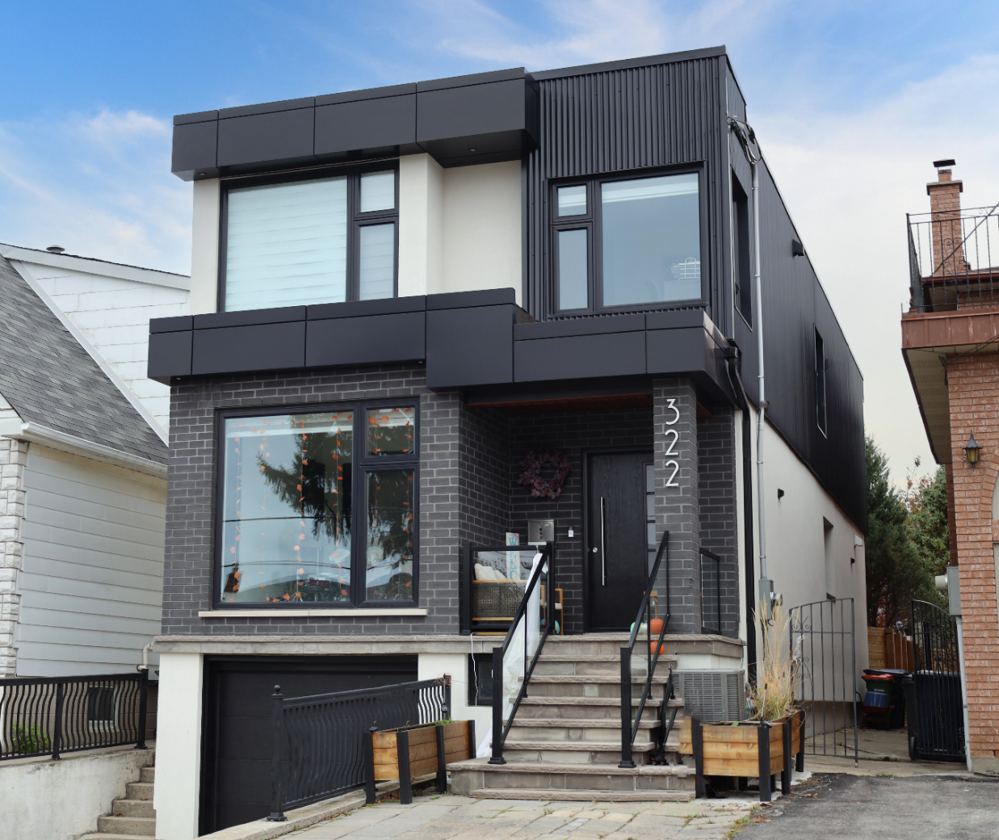
Industrial / Residential / Commercial / Agricultural
Durable, stylish, and cost-effective, metal siding panels offer a modern and long-lasting solution for residential and commercial projects. Made from high-quality steel, these panels provide excellent protection against harsh weather, fire, and pests while enhancing energy efficiency. Their low maintenance requirements and longevity make them a budget-friendly choice over time. With a variety of profiles, finishes, and colors available, metal siding delivers both aesthetic appeal and structural resilience, making it a smart investment for any building.
Curious about the advantages of steel siding? Visit our blog to explore the compelling reasons why this choice stands out for homeowners seeking durability and style.
Speak with an Expert Get personalized advice and expert guidance to achieve your project goals with confidence.
HIDDEN FASTENING (HF) SERIES MENU ICON (PREVIEW)

HIDDEN FASTENER (HF) SERIES Steel Siding & Soffit
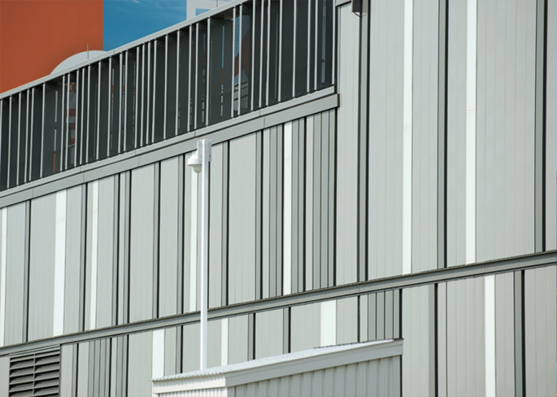
Hidden or Concealed fastening steel siding systems offer a clean, modern aesthetic with exceptional performance across residential, commercial, and industrial applications.... (Learn More / Expand)

HIDDEN FASTENER (HF) SERIES Steel Siding & Soffit (EXPANDED)
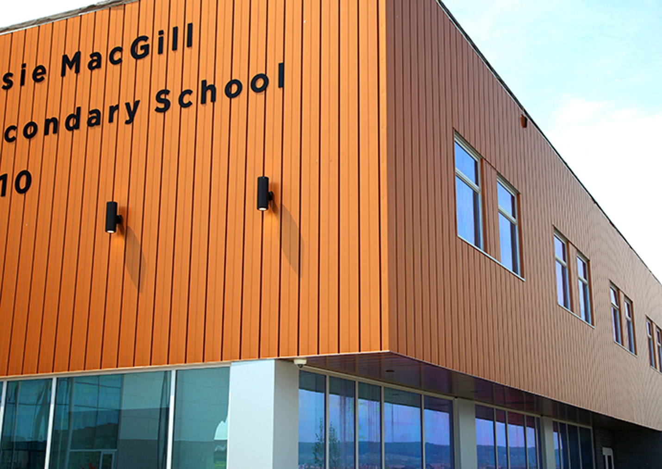
Expanded …By hiding fasteners behind interlocking panels, these systems provide a sleek, uninterrupted exterior surface that enhances visual appeal while improving long-term durability. The concealed design not only protects fasteners from weather exposure and corrosion but also reduces maintenance needs and increases lifespan. With a variety of profiles, colors, and finishes available, these systems deliver both architectural versatility and structural integrity—making them an ideal solution for projects demanding style, strength, and reliability

1- AGWAY BOARD & BATTEN MENU ICON (PREVIEW)

Agway Stratus Steel Siding Board & Batten
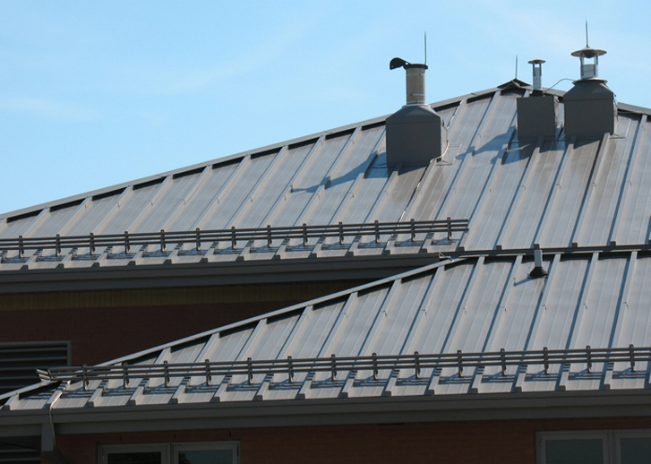
Agway offers two architecturally striking batten-style profiles—Board & Batten and Diamond Batten—each designed to bring depth, rhythm, and visual interest to building exteriors..... (Learn More / Expand)

AGWAY® BOARD & BATTEN HIDDEN FASTENER (HF) SERIES (EXPANDED)
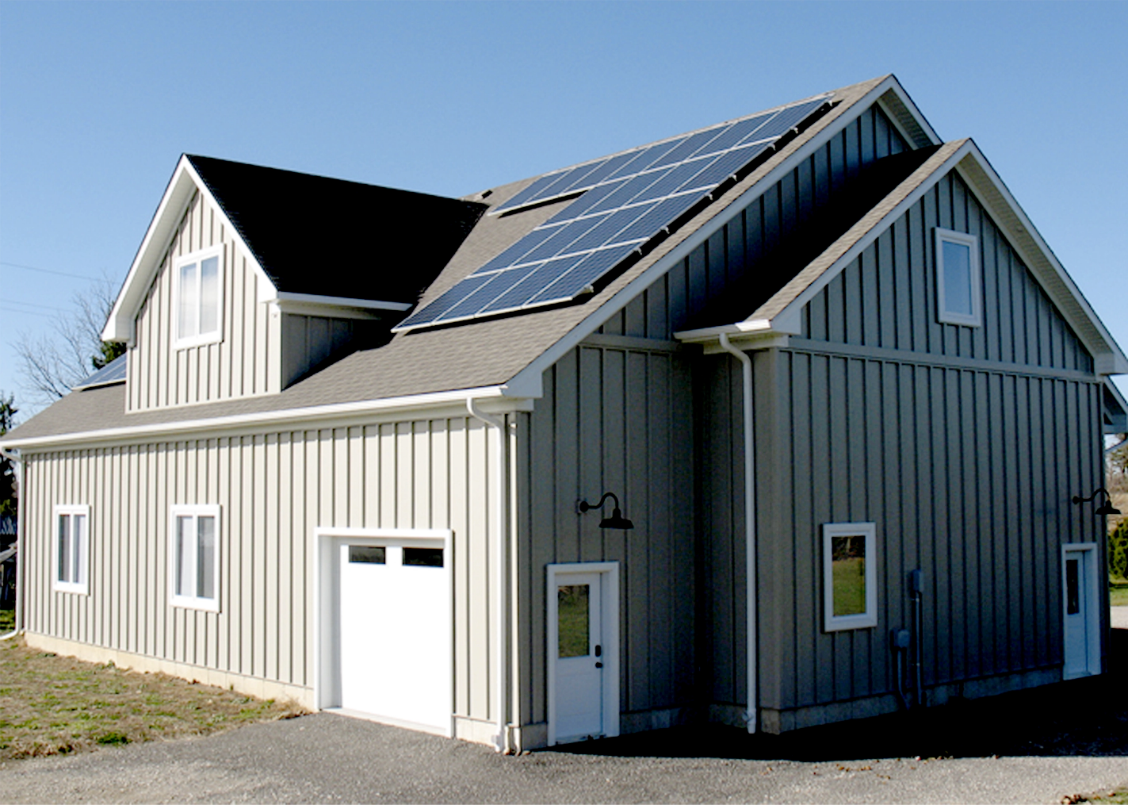
Expanded … Agway offers two architecturally striking batten-style profiles—Board & Batten and Diamond Batten—each designed to bring depth, rhythm, and visual interest to building exteriors. With customizable widths and lengths of up to 20 feet, these profiles offer excellent design flexibility for both wall cladding and roofing applications across residential, commercial, and institutional projects.

Profiles:
Crafted from high-performance materials like pre-painted steel, aluminum, copper, stainless steel, and zinc, they provide not only long-term durability but also a distinctive aesthetic. Whether you’re aiming for a rustic-modern contrast or a clean, contemporary finish, these batten profiles offer a timeless look with the resilience of metal.

Board and Batten (Brake-Formed)
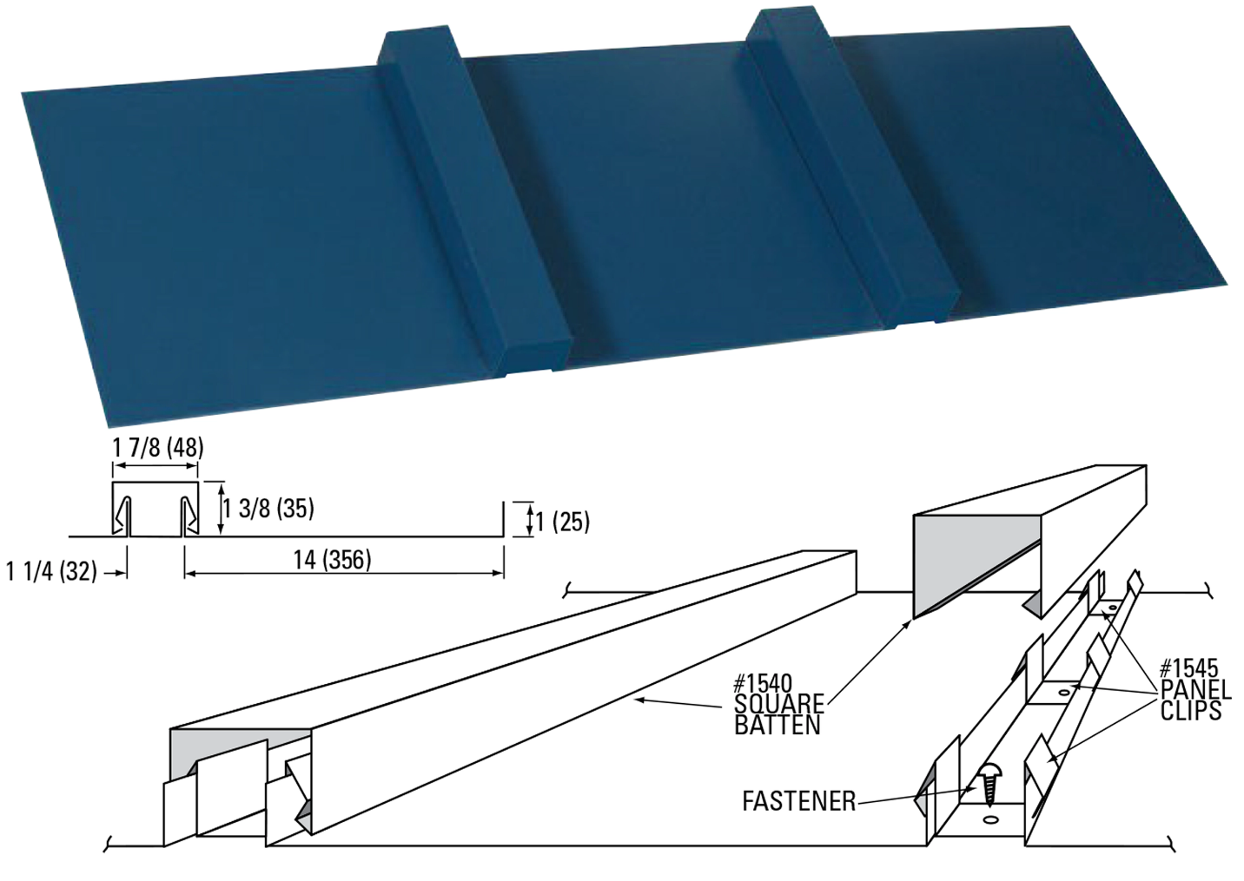
Engineered for versatility, it features a hidden fastener system for a clean, streamlined look with secure installation. Manufactured in 26-gauge steel and available in custom lengths from 12” to 384”, Stratus adapts effortlessly to a variety of applications, including accent panels, vertical and horizontal walls, and soffits. With precision-engineered concealed screw slots for easy installation, it delivers both style and strength, ensuring a flawless finish for any project.

Features
- Custom lengths available from 1’-0” to 20’-2”
- Material options: Prepainted Steel, Aluminum, Copper, Stainless Steel, and Zinc
- Includes starter cleat and 90° end bend (upon request)
- Suitable for both roof and wall applications
- Can be notched and preformed for knee-bend installations
- Custom dimensions available to meet specific requirements
- Important: All installations must be on solid decking with a moisture barrier

Diamond Batten (Brake-Formed)
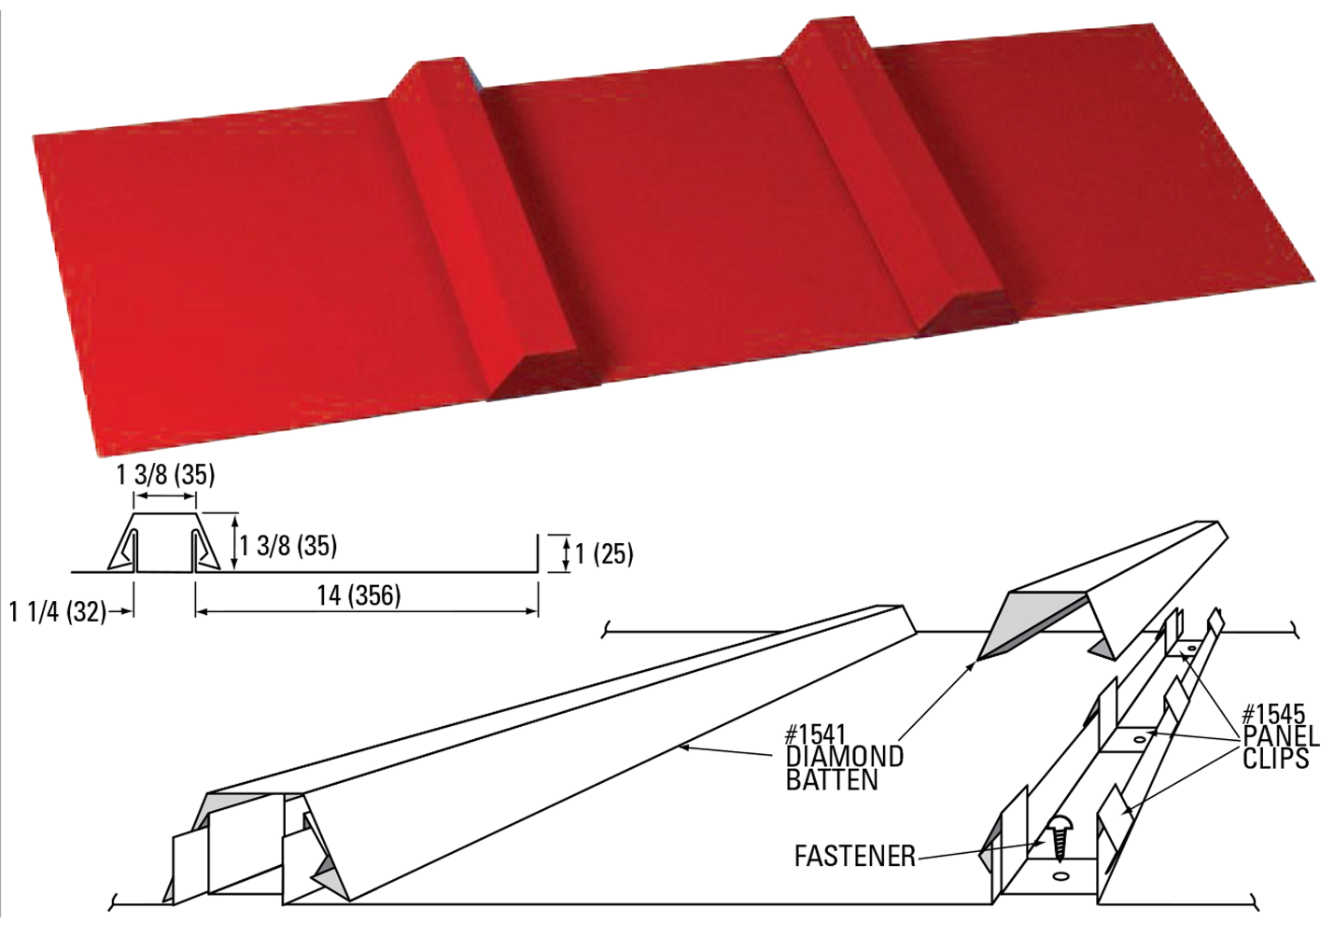

Features
- Custom lengths available from 1’-0” to 20’-2”
- Material options: Preprinted Steel, Aluminum, Copper, Stainless Steel, and Zinc
- Available with a starter cleat and 90° end bend
- Suitable for both roof and wall applications
- Custom dimensions available to meet specific requirements
- Important: All installations must be on solid decking with a moisture barrier

Additional Notes:
- Please note: Oil canning may naturally occur due to material and installation variables.
- This is a visual phenomenon and does not qualify as a product defect.

Color chart

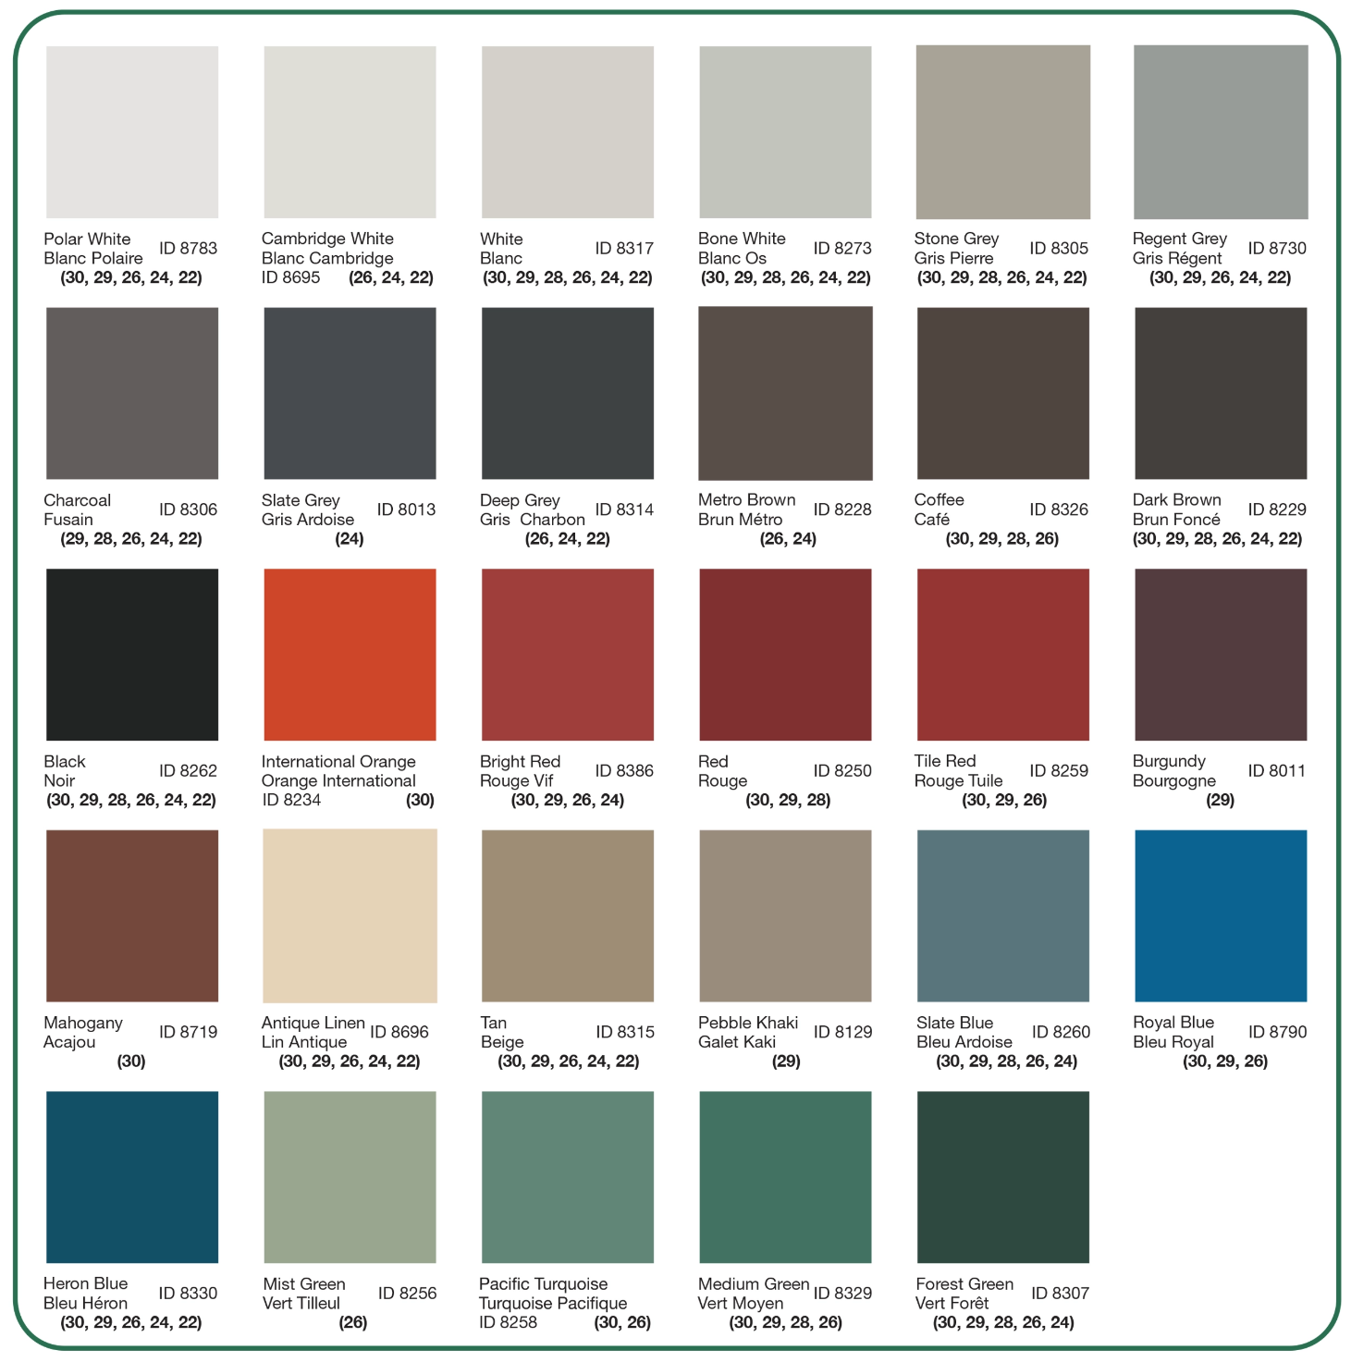

Standard and Custom Flashings
If you need a specific flashing shape, we can fabricate it. Cladcan provides a full range of flashings and trims to complete your commercial or industrial building project. From outside corners to jambs and coping flashings, we’ve got you covered.

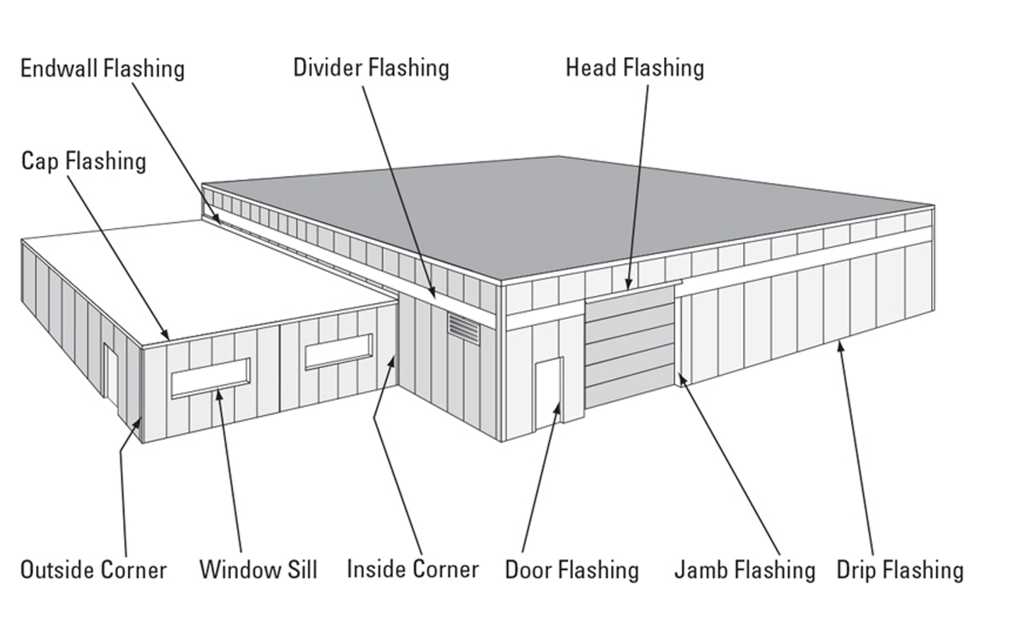

Outside and Inside Corners
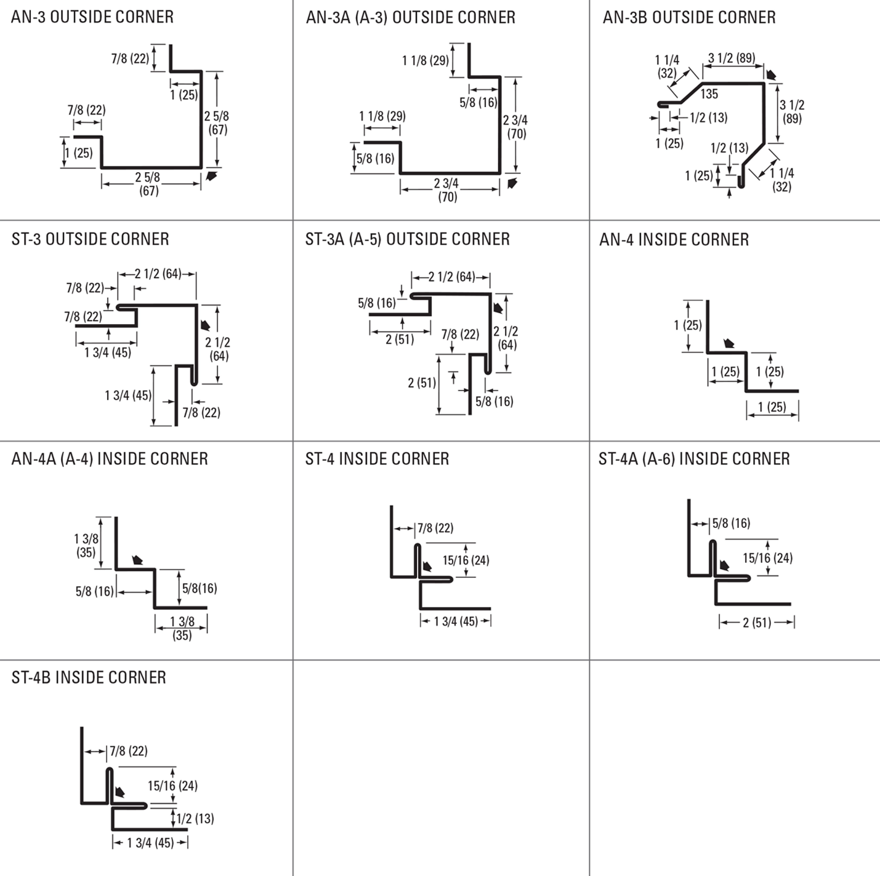

Drip and base Trims, Gable Dividers
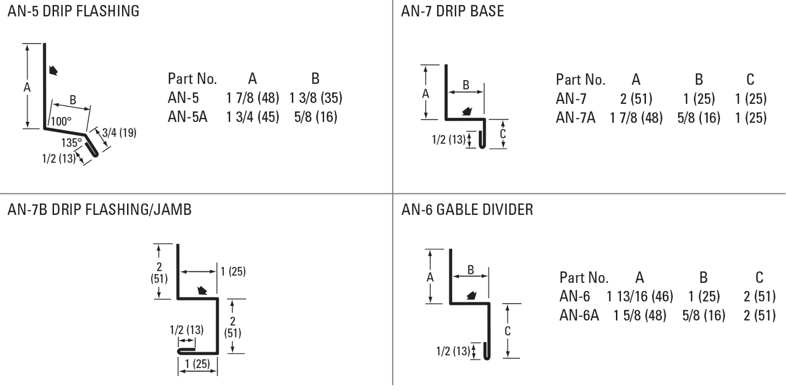
Soffit & Gable Trims, Eaves Starters, Jamb Fkashings
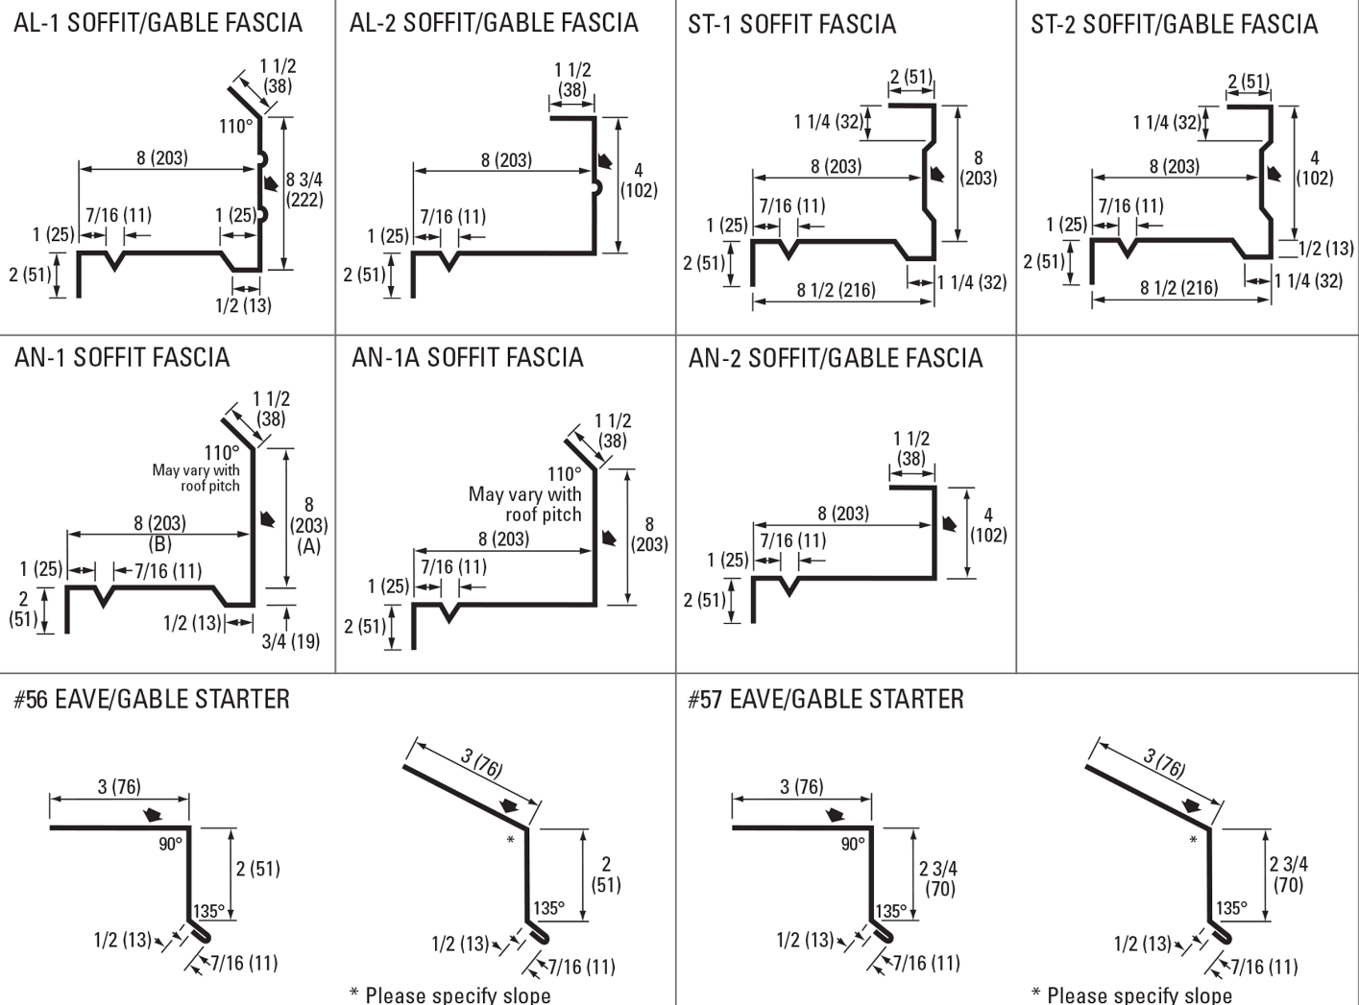
Hip Flashings, Endwalls, J-Trims, Ceiling & Sliding Door Trims
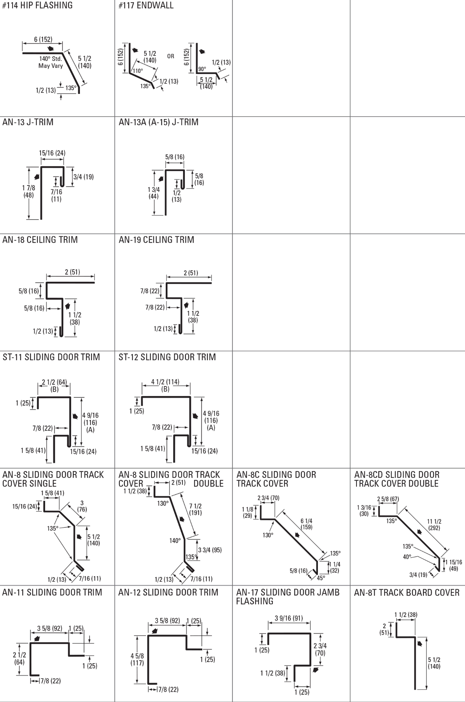
Finishes Perspectra Plus Series™
The Perspectra Plus Series™ represents the next evolution of our Perspectra Series® paint system. Enhanced with advanced Silicone Modified Polyester (SMP) technology and a new resin backbone, it offers superior resistance to chalking, fading, chemical degradation, and scratching.
Designed for maximum durability, the Perspectra Plus Series™ provides exceptional colour fade resistance, improved gloss retention, and increased scratch resistance. With a proven track record, it ensures 40 years of film integrity and 30 years of reliable colour and chalk resistance, making it ideal for roofing and cladding applications across Canada and the continental US.
Available on hot-dip galvanized steel and Galvalume™ (55% Aluminum – 45% Zinc alloy coating), the Perspectra Plus Series™ guarantees long-lasting performance and outstanding protection.

